Making EC2 Instance
Step 1:
Turn on the Lab
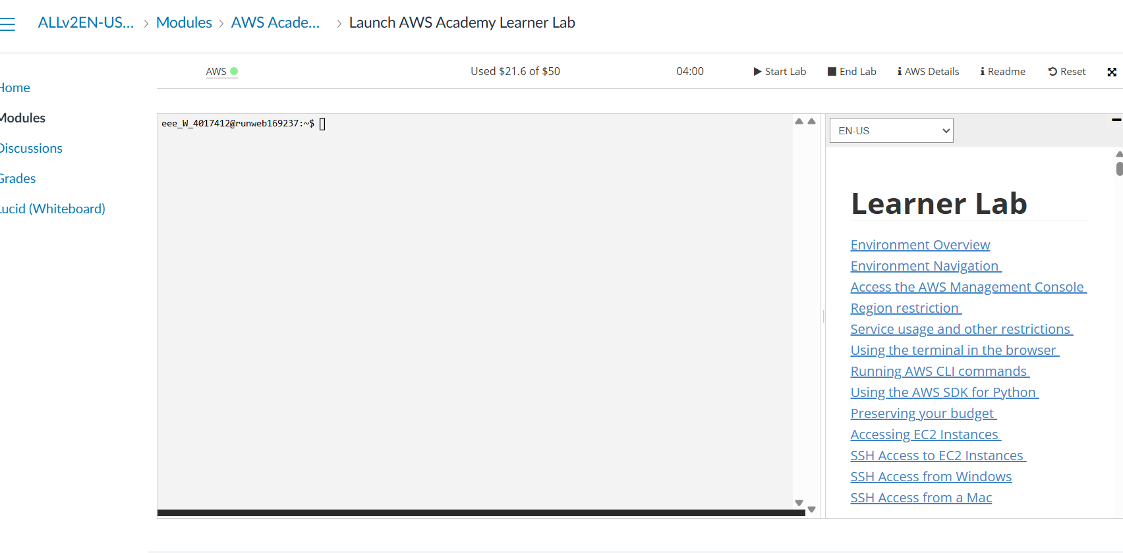
Step 2:
Open up AWS Console
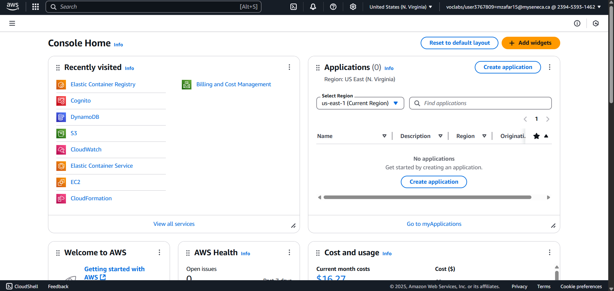
Step 3:
Open EC2
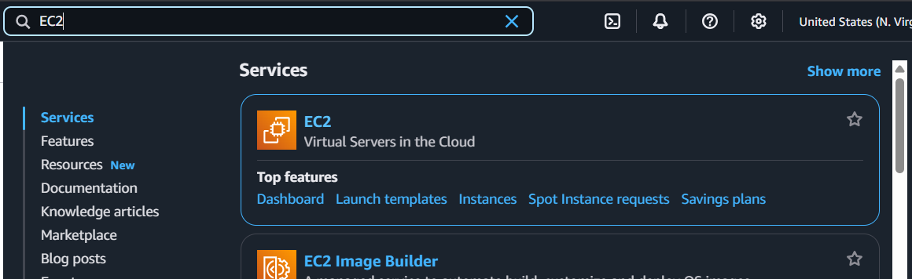
Step 4:
Click Launch Instance
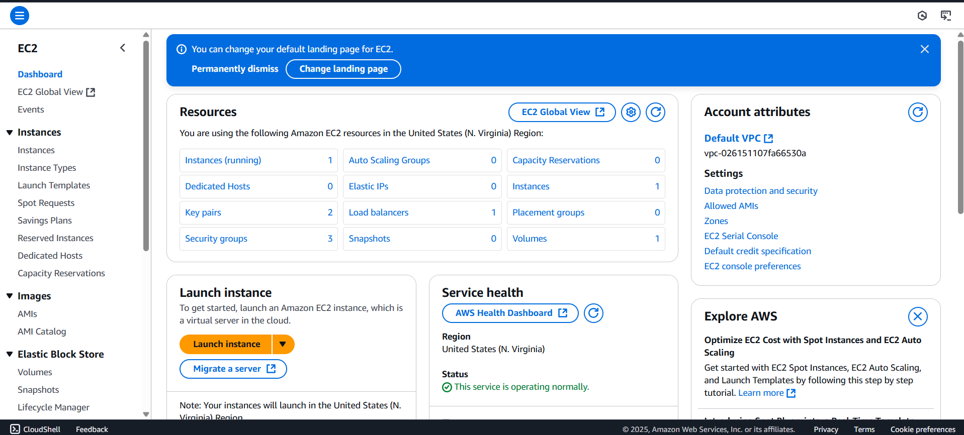
Step 5:
Choose a name
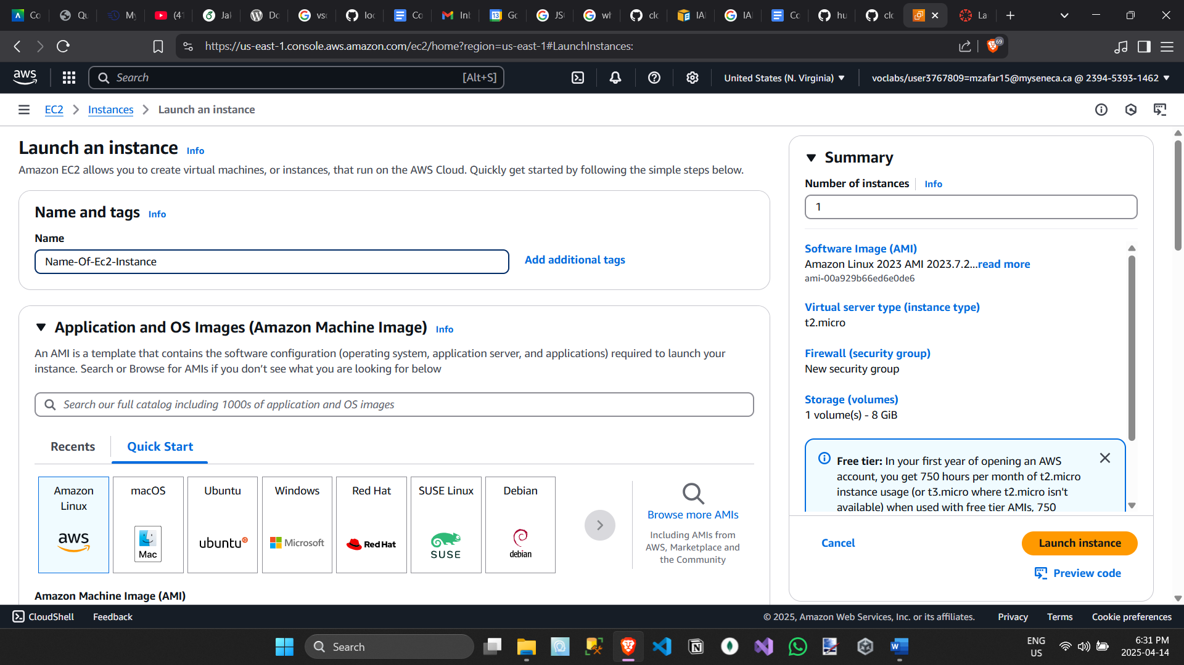
Step 6:
Select The Amazon Machine Image (AMI)
- Choose
  - Amazon Linux 2023 AMI
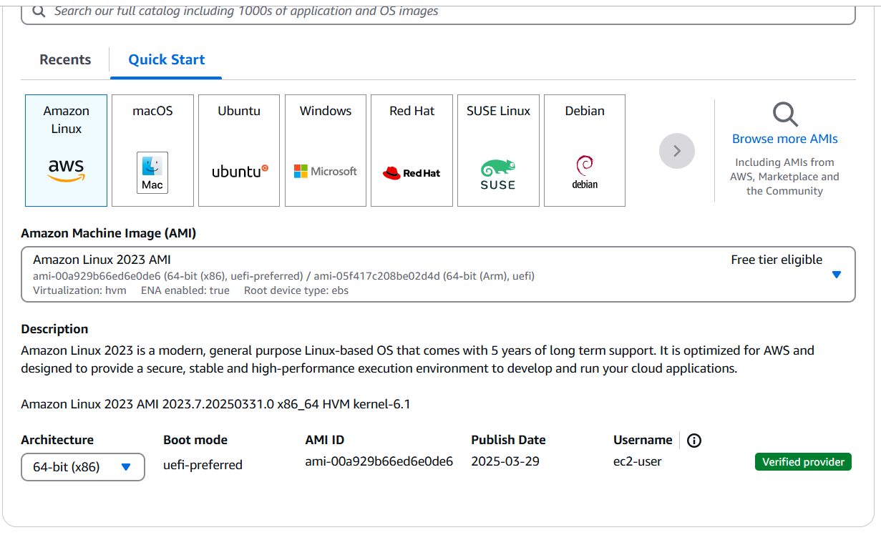
Step 7:
Choose an instance type
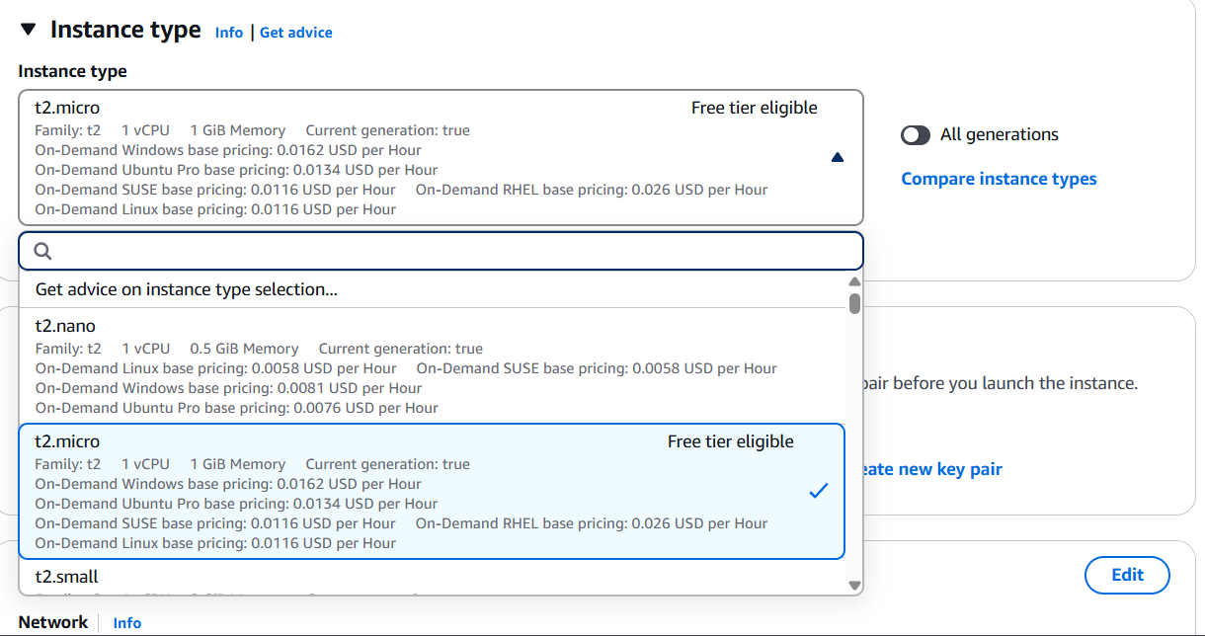
Step 8:
Create a key pair
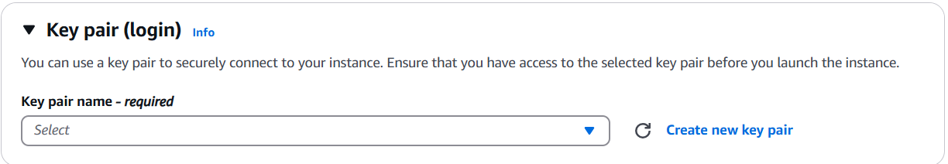
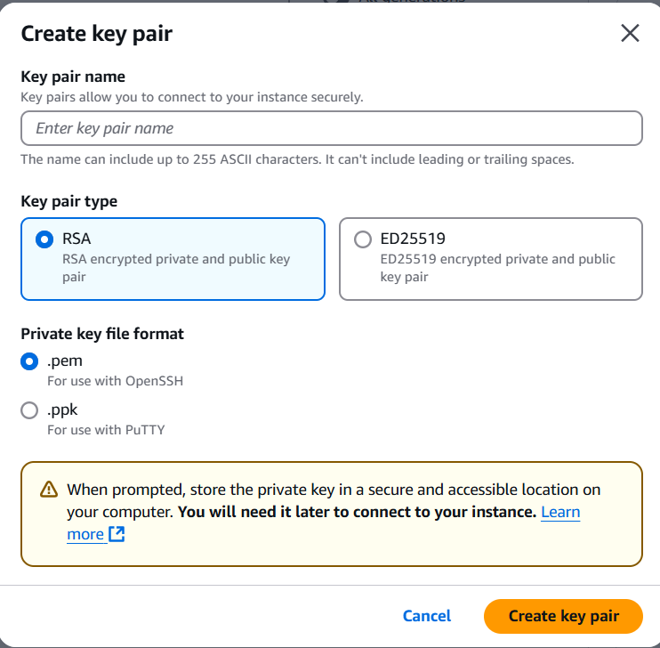
Step 9:
Setup a security group (virtual firewall)
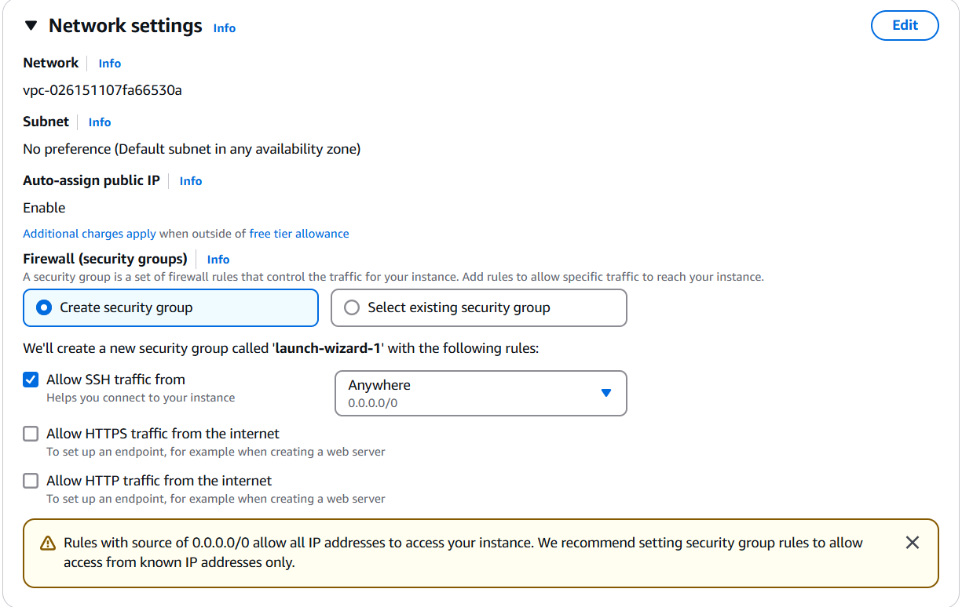
Step 10:
Click Edit to add a new security group rule
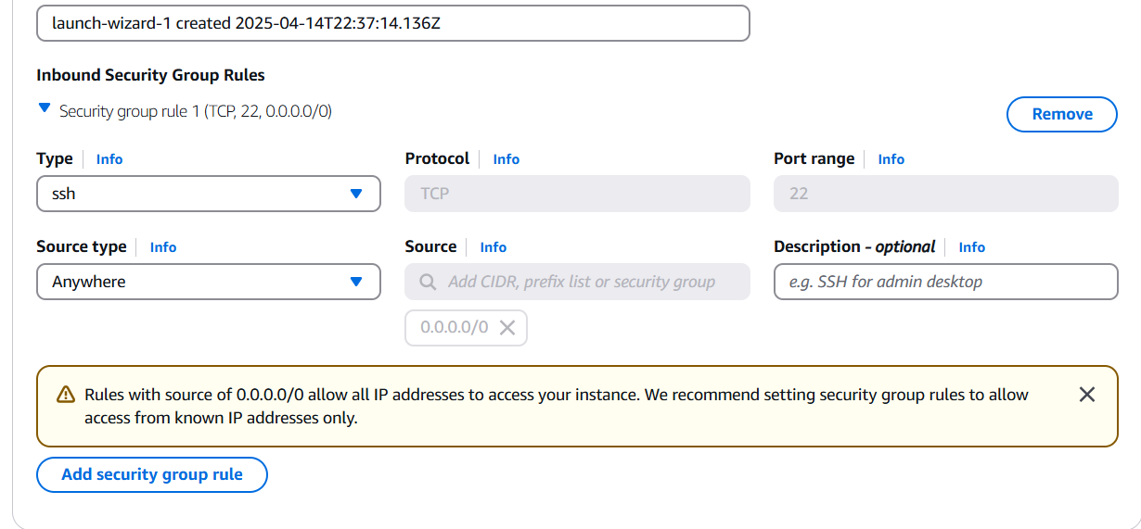
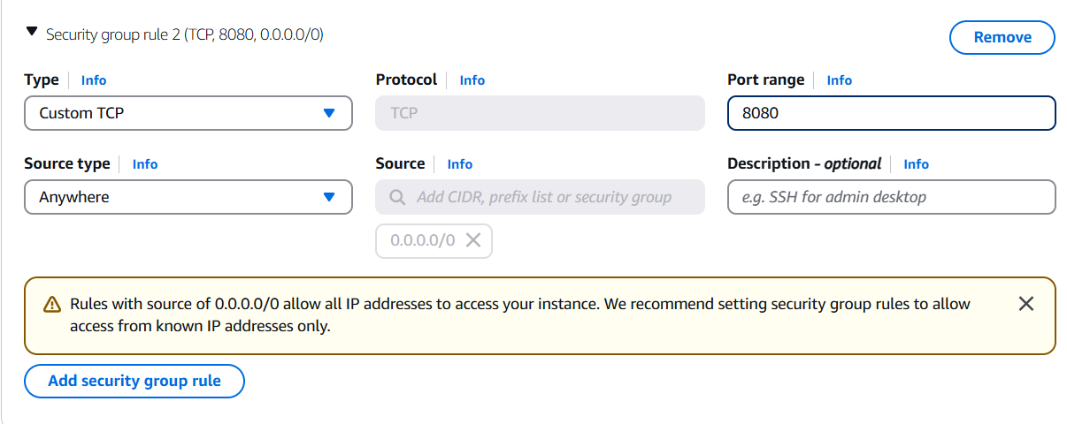
Step 11:
Configure Storage
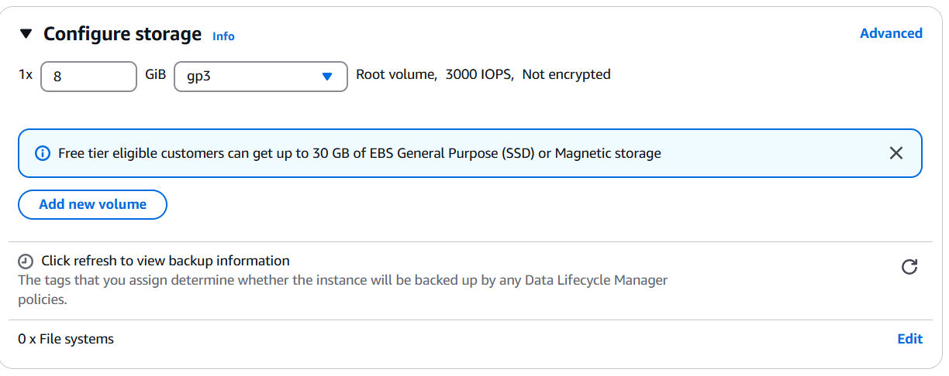
Step 12:
Set AWS account permissions for EC2 instance, with IAM roles
- Select Advanced Details
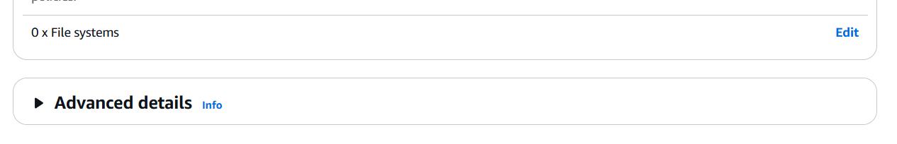
Step 13:
Under IAM instance profile, Set the profile
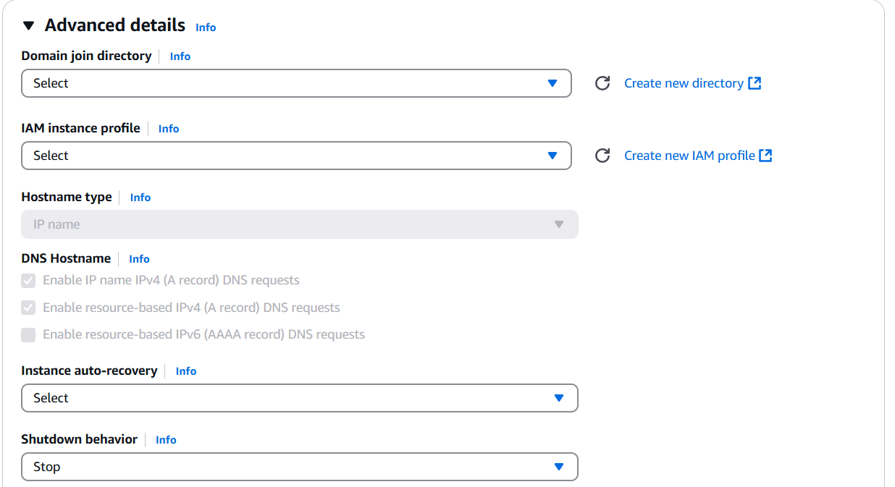
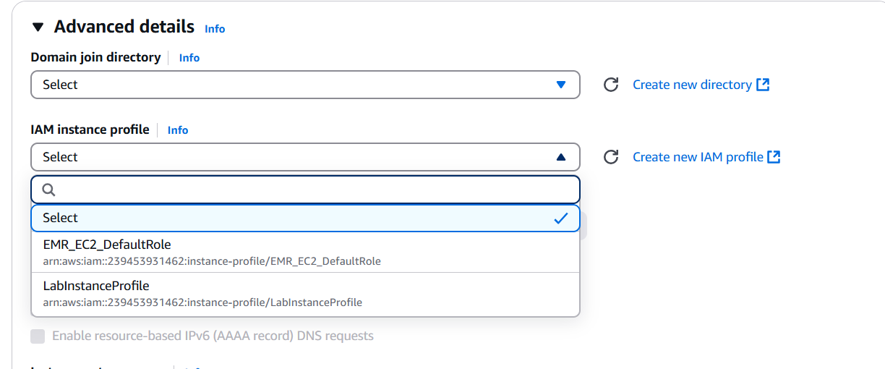
Step 14:
Step the number of instances (can just leave at 1)
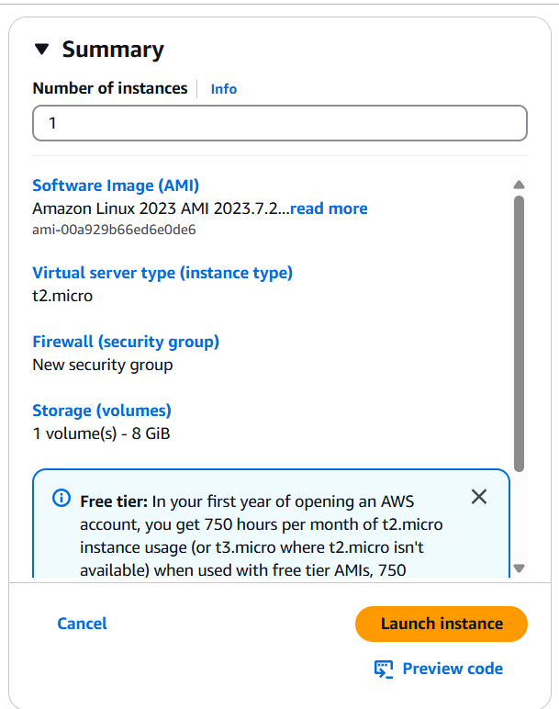
Step 15:
Press Launch Instance
